XSLT Assignment
- Consider Following XML
<?xml version="1.0" encoding="UTF-8"?>
<addressBook>
<entry id="1">
<name>Wayne</name>
<address>Room 4/536</address>
<email>brookes@it.uts.edu.au</email>
<workphone>1872</workphone>
<birthday>2001-01-01</birthday>
</entry>

<entry id="2">
<name>Maolin</name>
<address>Room 4/520</address>
<email>maolin@it.uts.edu.au</email>
<workphone>1858</workphone>
<birthday>2001-01-01</birthday>
</entry>
</addressBook>

Write an XSL file which produces following output.
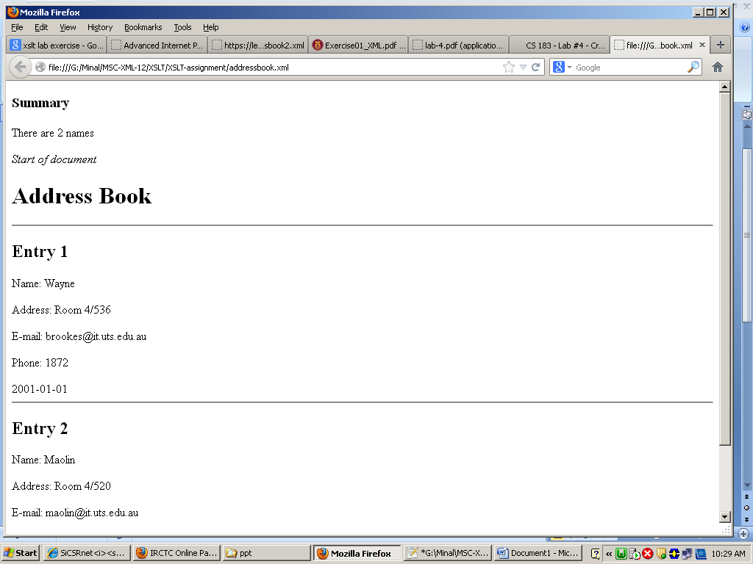

- Consider Following XML

<Staffs>
<EMPLOYEE>
<ID>A301</ID>
<NAME>ALI MAJID</NAME>
<GENDER>MALE</ GENDER>
<SALARY> 2110</SALARY>
</EMPLOYEE>
< EMPLOYEE>
<ID>A302</ID>
<NAME>FAIZAH BAKRI</NAME>
<GENDER>FEMALE</ GENDER>
<SALARY> 3060</SALARY>
</EMPLOYEE>
< EMPLOYEE>
<ID>A303</ID>
<NAME>GHADDAFI KAMAL</NAME>
<GENDER>MALE</ GENDER>
<SALARY> 1725</SALARY>
</EMPLOYEE>
<EMPLOYEE>
<ID>A304</ID>
<NAME>AHMAD ROMIZI</NAME>
<GENDER>MALE</ GENDER>
<SALARY> 2174</SALARY>
</EMPLOYEE>
<EMPLOYEE>
<ID>A305</ID>
<NAME>RICHARD TEH</NAME>
<GENDER>MALE</ GENDER>
<SALARY> 1930</SALARY>
</EMPLOYEE>
<EMPLOYEE>
<ID>B533</ID>
<NAME>PREM MOHAN</NAME>
<GENDER>MALE</ GENDER>
<SALARY> 2215</SALARY>
</EMPLOYEE>
<EMPLOYEE>
<ID>B534</ID>
<NAME>NORFAEZAH KASMURI</NAME>
<GENDER>FEMALE</ GENDER>
<SALARY> 1990</SALARY>
</EMPLOYEE>
<EMPLOYEE>
<ID>B535</ID>
<NAME>AIDA AYOB</NAME>
<GENDER>FEMALE</ GENDER>
<SALARY> 2150</SALARY>
</EMPLOYEE>
<EMPLOYEE>
<ID>B536</ID>
<NAME>MUZZAN SHAZMIN</NAME>
<GENDER>FEMALE</ GENDER>
<SALARY> 1860</SALARY>
</EMPLOYEE>
<EMPLOYEE>
<ID>B537</ID>
<NAME>FIKRI ABDULLAH</NAME>
<GENDER>MALE</ GENDER>
<SALARY> 1810</SALARY>
</EMPLOYEE>

2a) Write an xsl file to produce following output
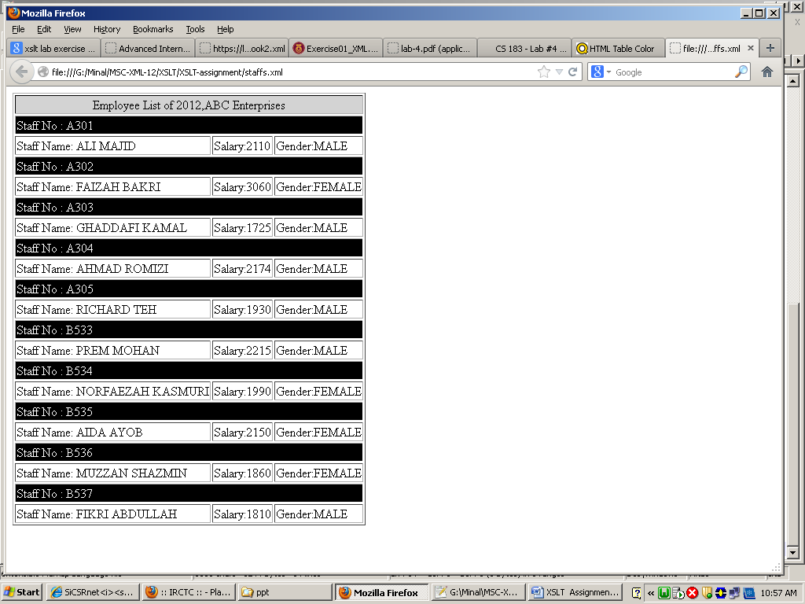

2b) sort the salary data in ascending order. Also display Total salary and staff Count in last row.
2c) Only display the data in table if gender is female. Also display Total salary and staff Count in last row.
2d) Add grade column ,assumption for grade as follows
- If salary > 3000 , grade=CEO
- If salary > 2600 , grade=Senior Manager
- If salary > 2000 , grade=Manager
- Grade=worker
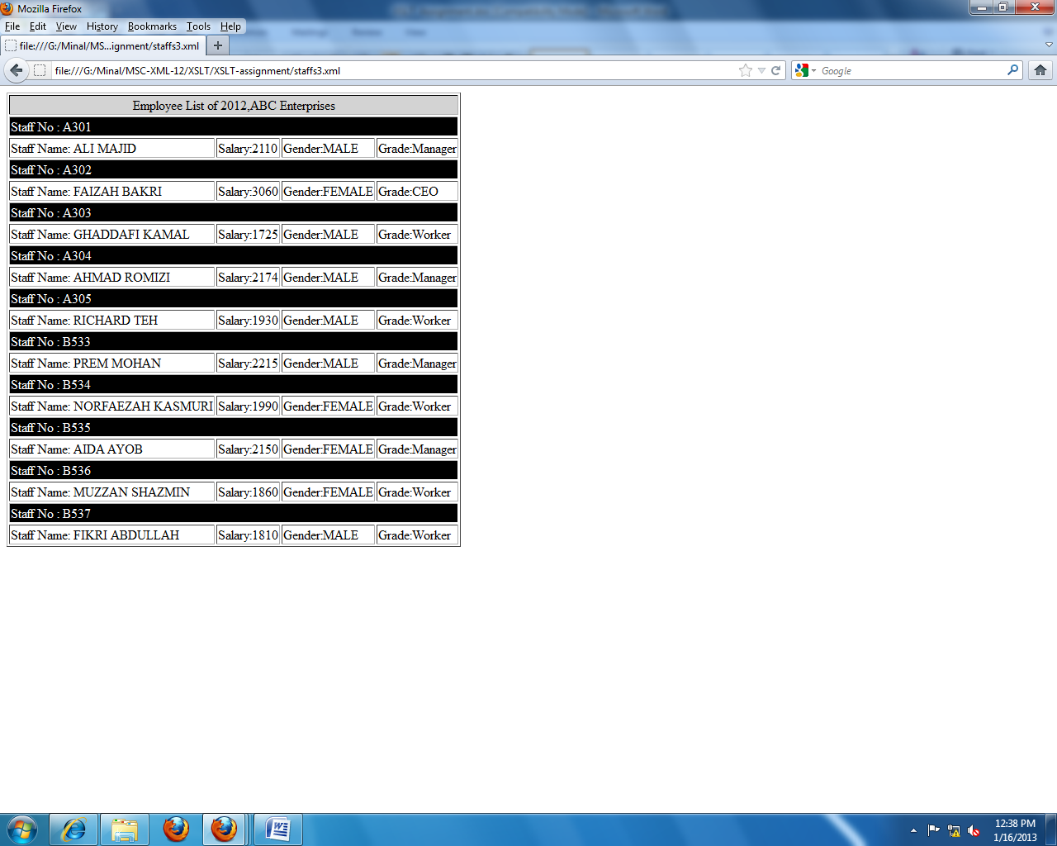

3)Consider Following XML
<?xml version="1.0" encoding="UTF-8"?>
<CDcollection>
<CD>
<composer>Johannes Brahms</composer>
<soloist>Emil Gilels</soloist>
<orchestra>Berlin Philharmonic</orchestra>
<conductor>Eugen Jochum</conductor>
<date>1972</date>
<performance>
<composition>Piano Concerto No. 1</composition>
</performance>
<publisher>Deutsche Grammophon</publisher>
<number>419159-2</number>
</CD>

<CD>
<composer>Johannes Brahms</composer>
<soloist>Emil Gilels</soloist>
<performance>
<composition>Piano Concerto No. 2</composition>
<orchestra>Berlin Philharmonic</orchestra>
<conductor>Eugen Jochum</conductor>
<date>1972</date>
</performance>
<performance>
<composition>Fantasias Op. 116</composition>
<date>1976</date>
</performance>
<publisher>Deutsche Grammophon</publisher>
<number>419160-2</number>
</CD>

<CD>
<soloist>Martha Argerich</soloist>
<orchestra>London Symphony Orchestra</orchestra>
<conductor>Claudio Abbado</conductor>
<date>1968</date>
<performance>
<composer>Frederic Chopin</composer>
<composition>Piano Concerto No. 1</composition>
</performance>
<performance>
<composer>Franz Liszt</composer>
<composition>Piano Concerto No. 1</composition>
</performance>
<publisher>Deutsche Grammophon</publisher>
<number>449719-2</number>
</CD>

<CD>
<composer>Antonin Dvorak</composer>
<performance>
<composition>Symphony No. 9</composition>
<orchestra>Vienna Philharmonic</orchestra>
<conductor>Kirill Kondrashin</conductor>
<date>1980</date>
</performance>
<performance>
<composition>American Suite</composition>
<orchestra>Royal Philharmonic</orchestra>
<conductor>Antal Dorati</conductor>
<date>1984</date>
</performance>
<publisher>Decca</publisher>
<number>430702-2</number>
</CD>
</CDcollection>

Write an xsl file to produce following output
